**SIMPLE DOUBLE PARALLELOGRAM LIFTING MECHANISM**

**MENG 3303-032 DYNAMICS OF MACHINERY PROPOSAL**

**MENG 3303-032** **Aws Al-Shalash**

**Group #16**

**REPORT SUBMITTED BY:**

**Mashoud Kabore**

**Michael Peterson**

**Mohammed Waheed**

**Miheretsilasie Zewde**

We certify that the narrative, diagrams, figures, tables, calculations and analysis in this report are our own work.

**DATE REPORT DUE:            December 11, 2019**

**DATE REPORT SUBMITTED:            December 11, 2019**

**MECHANICAL ENGINEERING DEPARTMENT**

**HOUSTON ENGINEERING CENTER**

**COLLEGE OF ENGINEERING**

**THE UNIVERSITY OF TEXAS AT TYLER, HOUSTON ENGINEERING CENTER**

**Abstract**

The challenge that was presented was to design a mechanism with the specified requirements of achieving a goal, where a prop was to be lifted for a practical effect in post media production. This was done by designing a parallelogram lift that conforms to set parameters. The parallelogram lift is able to lift from its resting position to its maximum height of 4.75 inches. It also is capable of lifting 6 pounds. The prototype that was designed by SolidWorks and was analyzed on its displacement, velocity, acceleration, and torque to determine if the calculated results were correct within acceptable certainty. Once the SolidWorks analysis was compared to the calculated results the prototype was found to have been working in a valid condition to fulfil its purpose within its proposed parameters.

**Table of Contents**

Introduction………………………………………………………………………………....……….4

Problem Statement………………………………………………………………………....………..5

Objective…………………………………………………………………………………………….5

Preliminary Literature Review………………………………………………………………………5

Methodology……………………………………………………………………………...…………6

Discussion and Results…………………………………………………………………………….14

Conclusion………………………………………………...………………………...……………..16

References…………………………………………………………………………...……………..17

Appendices…………………………………………………………………...…………………….18

Appendix A ..………………………………………………………………...…………………….18

Appendix B ..………………………………………………………………...…………………….19

**Introduction**

A Double Parallelogram Lifting Mechanism is a simple machine which works using a crank or motor to lift heavy objects smoothly. The machine is designed using two parallel tables along with a series of links and a threaded rod placed perpendicular to the links. The load is placed on the table and the crank turns a system, which raises or lowers the table/load [1].

The motivation and objectives for the design of the Parallelogram Lifting mechanism is to tackle a difficult task with ease. The purpose of this machine, in general, is to lift/lower an object to a certain height and lower as necessary. This mechanism can be used in a variety of ways depending on the industry. The weight of the object, the size of the object, the speed necessary to lift the object, and even the housing space are all factors of motivation for this design. For example, until the 1980s automotive garages were designed with a pit [2]. The car was driven into place over an open well where the mechanic stood. With the wide variety of car sizes, this garage design has become obsolete. The lift mechanisms have made the ability for a mechanic to work on various sizes of vehicles easier.

Another example can be found in the movie industry this mechanism is mostly used to lift a heavy object or person up or down for certain parts of the movie, to make a person quickly rise from the ground to create a jump scare, or to slowly lower them to the ground.  A prime example of this use would be in the movie *Star Wars: Episode V--The Empire Strikes Back*when the character Han Solo was lowered into a pit and then raised to be found frozen in carbonite. This scene was possible by using a lift mechanism.

The advancement of parallelogram lifting mechanism is important in many industries. In the movie industry, it is also desirable to have different size lifts. The size of the lift needed to lift a human does not need to be the same size as one needed to lift a large heavy prop like a car or spaceship. Since the Double Parallelogram Lift Mechanism could be made in various sizes, it makes it ideal in the movie industry and automotive industry. These mechanisms are often needed to be hidden in a scene, and size and strength are a great attribute to this design making it extremely sought after in the movie/theatre industries.

**Problem Statement**

The challenge presented is to lift, hold, and move heavy or cumbersome objects such as props for a movie/theatre production. By having a Double Parallelogram Lifting Mechanism, the ease of lifting and moving items around a stage/set allow for the a practical effect to be preformed in media post-production. This mechanism can also be utilized in the production itself, allowing for better special effects.

**Objectives**

The objective for the Double Parallelogram Lifting Mechanism is to design a simple machine which will lift heavy loads easily. Designing such a machine will help people in the movie/theatre industry. In the theatre, large props can be easily moved utilizing the Double Parallelogram Lifting Mechanism. The theatre can also use the mechanism as a trapdoor, allowing for the raising and lowering of an actor. The Double Parallelogram Lifting Machine is ideal on the movie set for lifting and moving large movie cameras around the production sight. The design will be easily modified to suit the desired job (size of object). Since this product can be used repeatedly, cost-effectiveness and overall productivity will increase.

**Preliminary Literature Review**

The article by Reltech[1] describes the parallelogram lift is a mechanism that is designed using two parallel tables along with a series of links and screws. This machine is heavily inspired by the parallelogram lift and scissor jack that belongs in most automobiles. To determine change each link should take in this mechanism when seeing how the scissor jack worked. The article which goes over a power scissor jack[3] helps one to determine change each link should take in this mechanism when seeing how the scissor jack worked. it was analyzed the mechanism and found that the 2 links that were supported by a threaded rod and were able to find how much force is needed to sustain about its axis on each end to hold the lift and be perpendicular to it.

**Methodology**

In the approach of designing the double parallel lift the first step was to come up with the basic layout of parts that are comprising of the mechanism. This will result in wanting to make sure the parts are feasible when 3D printing them. Due to this, a different way to use what tools are available and how it would work in these constraints. One example was the immediate challenge that was to find a way for links to move in rotation along the gear mechanism. So, when moving forward in designing this product it was must to first list the parameters in what will be placed as constraints over the mechanism. This system must still have the continuous crank parameter which may be a challenge due to the nature of how the mechanism has a maximum turn on the crank and no way of continuing the crank to have a retraction of the lift. This can be fixed by switching the threaded perpendicular axle to gear rotation off of a gear rack attached to a crank slider. This will then allow crank to be turning continuous while lifting the attached platform and descending the platform while the crank turns in the same direction. Next was to design a way for everything to be turning continuously with a constant velocity that would allow the mechanism to work while being symmetrical. This step was done by making the mechanisms gears that would be direct contact with links pushing the lifting platform to be aligned in parallel and to have the same ratio of number of teeth and pitch diameter.

The product was created by using a software called SolidWorks. The process in creating this assembly started by first making the parts. Each part was made by having in mind what range of motion would be.

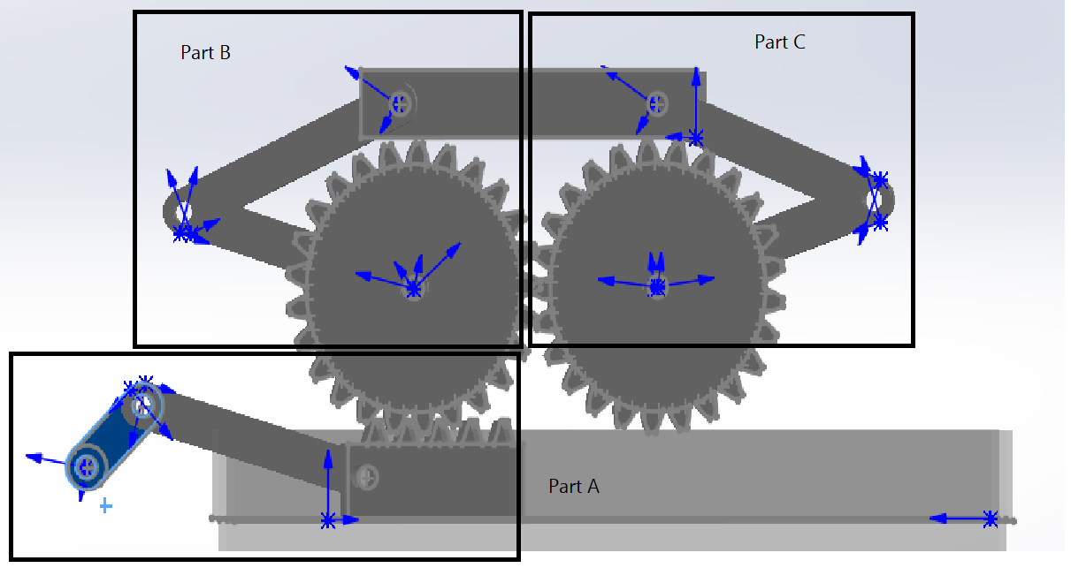

**Fig. 1.** Proposed assembly of bar mechanism for a parallelogram lift

The product can be analyzed by breaking it into three sections as shown in the **Fig. 1**.

**Determining Position and Velocity**

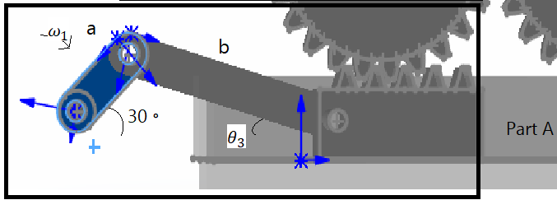

**Fig. 2.** Part A of the mechanism which shows a slider crank which powers the parallelogram lift.

The analysis starts in part A of the mechanism where link a is being powered by a motor and having an angular velocity (ω) 10 rpm, link a = 1 in, link b = 3 in. Based on the angular velocity the slider position and velocity are found below using the equations. First part of is to find the position and distance link b is from link a this is done by finding the angle of link b ( $θ_{3})$ along the x-axis.

$$sin \left(\frac{sin θ }{b}\right)=θ_{3}$$

$θ_{3}$ = 9.59◦

The next step is to find the value of d

$$acos\left(θ\right) +bcos \left(θ_{3}\right) =d$$

d = 3.82 in

The next part of the analysis is to find the velocity of the slider. The slider acts as a gear rack on the mechanism which turns gear over it. The slider has 5 teeth and the gear has 25 teeth. Based on the found velocity when the crank has an angular velocity of 10 rpm the angular of velocity of the gear must be found. The first part of this must be to convert 10 rpm to radians/sec when doing the conversion, the angular velocity becomes 1.05 radians/sec. Now that has been established velocity must be found at point a. This can be done by multiplying the length of a and the angular velocity giving Va = 1.05 in/sec.

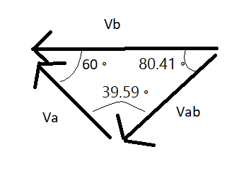

**Fig. 3.**  Shows the vector analysis being done to find each component.

Using vector analysis to find VB the formula is below will be used which is derived from the law of sines for triangles.

$$\frac{v_{ab}}{sin \left(60\right) }=\frac{v_{a}}{sin \left(80.41\right) }$$

$v_{ab}$ = .92 in/sec

$\frac{v_{b}}{sin \left(39.59\right) }=\frac{v_{a}}{sin \left(80.41\right) }$

$v_{b}$ = .68 in/sec

Now the velocity of the slider component of part A or otherwise known as gear rack is known the angular velocity can be found for the gears based on the pinion and rack formula below. The formula consists of the radius of r = radius of the gear 1.5 in, $ω_{1}$ = angular velocity of the gear, and Vr = velocity of the gear rack.

$$\frac{ω_{1}}{v_{Γ}}=\frac{1}{r_{p}}$$

$ω_{1}$ = .45 rad/sec counterclockwise

Now that the angular speed of a gear has been found the other gear angular speed of part C can be found. To do this the formula of driver gear to driven gear ratio must be used to find the angular speed of C.

$\frac{ω_{2}}{ω_{1}}=\frac{-N_{1}}{N_{2}}$

$ω_{2}$ = .45 rad/sec clockwise

Finally, in order to find the velocity of the lifting plate form that is connected by links from part B and C, the angular velocity of the gears found prior can be used for vector analysis.

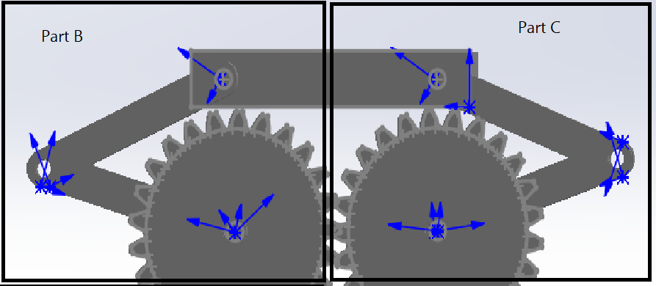

**Fig. 4.** This is a close up look at parts B and C

Due to the nature of the mechanism and how part B and C are mirroring each other along the y axis one can find that finding the velocity of the lift platform from either part B and C will be the same. Therefore, using only part B’s gear’s angular velocity to derive the velocity of the platform will equal the velocity that would be found using part C.

In order to find the lift velocity one can use the same method of deriving the crank slider.

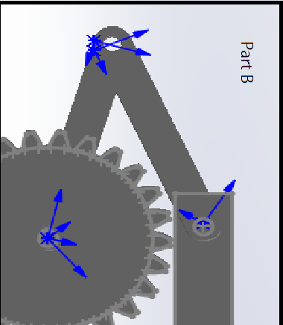

**Fig. 5.** Shows part B rotated for helping in vector analysis.

Due to constraint placed on link a which rotates along with gear the angular velocity of link a is the same as the gear .45 rad/sec. Links a and b are both 3 in long. Based on the calculations done before the lift platform can also be determined the same way the gear rack was determined. Next the position and angle of links a and b. Based on the constraint of link a, it s final angle when the gear is rotated to its maximum position will mean link a is 90 degrees from the x axis then the next step is to determine link a angle when cranks slider is positioned at 30 degrees as shown in **Fig. 2.** If the crank turning 180 degrees means the gear rack movement causes the gear to rotate 5 teeth or 72 degrees, which means that the resting position of link a and b is 18 degrees from the x axis. Since the crank is positioned at 30 degrees based on proportion is 12 degrees that can be added to the resting position of 18 degrees giving it a current position of 30 degrees. Now since link a is determined to be moving along the gear then it also is determined to have the same position as the gear is rotated. Another factor is that link a and b are both moving symmetrical along the joint that connects them, this means that link b has an angle of 30 degrees as well. From this information one can now derive the velocity diagram in finding the velocity of the lift platform based on the current position.

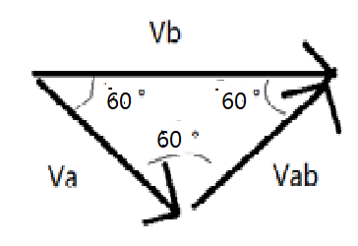

**Fig. 6.**  Shows the vector analysis being done to find each component.

Va = .45 rad/sec x 3 in = 1.35 in/sec

$\frac{v_{b}}{sin \left(60\right) }=\frac{v_{a}}{sin \left(60\right) }$

Vb = 1.35 in/sec

Since the lift platform is moving 1.35 in/sec in part B this is also true in part C making this the velocity of the platform if the initial crank is rotated from position of 0◦ to 30◦ clockwise.

**Determining Acceleration, Torque and Force**

In order to determine the acceleration of each component the values found for velocity from each part must be found. This can be found by making an force diagram of part A and finding all the components of force in order to find the value of the gear rack which acts as a slider. The force on the lift platform for this scale model since it has been scaled down by a factor of 6 is 6 lbf.

The first step to determine the acceleration of the lift platform is to determine find the acceleration of the gear rack based on the calculated acceleration of the crank, 1.103 rad/sec2 and the known angular velocity of the crank 1.05 rad/sec and link b .31 rad/sec. Using the formula below the acceleration of links a and b can be found for part A. Since link a of part A is the crank, therefore has the same acceleration known as $α_{2}$, the formula below will help find the acceleration of link b.

2 Counter clockwise

Below the formula gives the acceleration of the gear rack

$$a_{8}=-asinθ_{2}{α_{2}}-a\cos{θ_{2}ω_{a}^{2}}-b\sin{{θ_{3}α}_{3}}-b\cos{θ_{3}w_{b}^{2}}$$

$a_{8}=$ 1.75 in/sec2 left

Based on the acceleration found for the gear rack the acceleration of the gear of part B can be found. Since the gear radius is known to be 1.5 inches it can divided by the linear acceleration of the gear rack to find the angular acceleration of the gear giving it the value of 1.16 rad/sec2. Now using the formulas used prior to find the acceleration of the gear rack, the lift platform acceleration can be found for part B. As before stated since part B and C are identical then the acceleration found in part B is the same as found in part C. To find the angular acceleration of link b of part B the formula used to find $α_{3}$ is used and found to have a value of .57 rad/sec2. From this value of $α_{3}$ the acceleration of the platform can be calculated to have the value of .167 in/sec2.

Now to calculate the forces on the links and the torque on the crank, one must go about calculating it by starting from part B and C then finally calculating part A. Due to the force being inputted on the lift platform is 6 lbf and part B and C are equally taking the distributed force, it stands to reason that taking half the inputted force for the lift platform for part B will allow one to calculate the forces enacting on part C. Based on the model that is being constructed the parts will have properties of the material polylactic acid (density of .044 lb/in^3) that is being 3d printed. From the density the mass of each piece of part A is calculated and is listed as follow: link a = .020 lb, link b = .042 lb, and the slider = .091lb. For part B and C since they are made in the same parameters the weight of links a and b of part B will be the same as the links a and b in part C. The links a and b of part B are the same dimensions having a weight of .042lb. Now the next step is to determine the force knowing each link has a mass of .042 lb. This will be calculated by using a force matrix on each of the parts A, B, and C. Part B which also equates to part C, calculations will be shown below by matrix array.

**Table 1.** shows the initial input data of Part B of the mechanism



The torque and forces of the x and y axis are found on link a of part B that can also be translated to the gear of part B. Due to this impacting the gear of part B, one can now calculate the impact of torque that would drive the gear rack of part A from its contact of the gear. Since the gear has a torque of 1.3 lbf*in that can now translate to the force that is generated on the gear rack which comes to be .87 lbf at 0 degrees along the x axis. Now using the same method as before when using a matrix to compute the values to find the torque of the crank.

**Table 2.** shows the initial input data of Part A of the mechanism.



Now that the torque of the part A has been found the scaling factor can be applied to be found as 15.54 lbf *in.

**Discussion and Results**

A final take away of analysis is that the parallelogram lift is able to achieve its goal of lifting a prop for a practical affect for media production. The mechanism in its scaled down prototype form has met the goal of lifting a height from its resting position to its maximum height of 4.75 in. This mechanism was able to meet the requirement set on it and achieve its goal. And is able to provide enough force to lift an object of 6 lb by applying 15.54 lbf*in.

The next analysis that was done to further this mechanism was to now analyze the mechanism in the SolidWorks. Using SolidWorks with the parameters that were set for the calculations the following motion graphs were made where the crank turned 720 degrees.

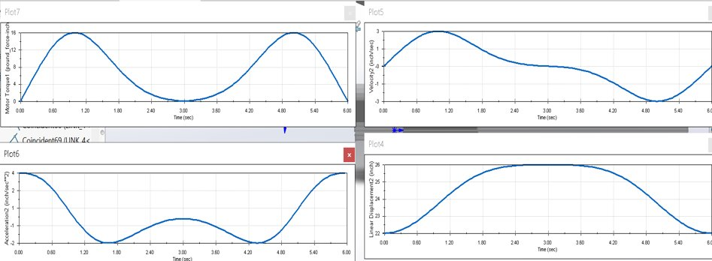

**Fig. 7.**  Shows the analysis done by SolidWorks on the mechanism. The Displacement, Velocity, and Acceleration graphs are of the platform. The torque is of the crank when the platform is lifting a force of 6 lbf.

From the values of the peaks of the graph trendlines shown from **Fig. 7.** The comparison with calculations can be made to see if they were done with proper technique. The comparison of the final value of the torque required to move 6 pounds of force on the plate form was 15.54 lbf * in, whereas the graph shows a value of 16lbf*in. This difference can be addressed to be due to the way significant figures were taken and values were rounded such as the when taking account of acceleration and the mass of each link in the calculation. Overall the analysis helps solidify the calculations that were done and ensure that the mechanism will work within its parameters.

**Conclusion**

In conclusion the mechanism that was proposed to solve the problem of having to lift a prop for a practical effect was a parallelogram lift. The parallelogram lift is seen in many industries, such as automotive and the factory settings. The lift has been redesigned to fit within parameters of the said goal and calculated. Finally, analysis was done on the mechanism using SolidWorks, as software used to design the mechanism, and was compared to the calculations that were done prior for confirmation. The mechanism has been found to complete the task it was set out to do and can be manufactured using the said parameters.

**References**

[1] “Design and Fabrication of Heavy Jack Using Double Parallelogram Mechanism.”

Retechprojects.com, <http://www.retechprojects.com/mechpdf/mechanism/REMF-125> Design and fabrication of heavy jack using double parallelogram mechanism.pdf.

[2] “Types of Auto Lifts: Automotive Lift Types.” *Automotive Lift Institute,* <https://www.autolift.org/auto-lift-institute-vehicle-lift-certification-program/auto-lift-types/>

[3] Babu, Sasank. “DESIGN AND FABRICATION OF A POWER SCISSOR JACK.” *LinkedIn SlideShare*, 8 Sept. 2015, https://www.slideshare.net/ssasankbabu/mergeddocument-52547137

[4] “Gears - General Gearing Arrangement.” *DesignAerospace LLC*, daerospace.com/mechanical-systems/gears-general-gearing-arrangement/.

**Appendences**

**Appendix A**

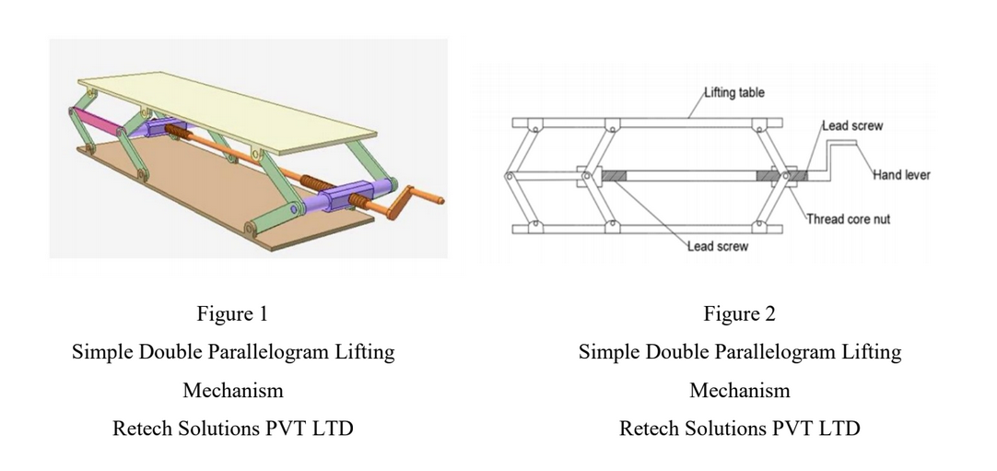

**Appendix B**



